Informational Text Resources
There are many informational/explanatory texts in series that may or may not be in use at a school (Rewards, Read Naturally, Horizons, etc...). If these series are NOT in use the stories can be “pulled” as sources to support non-fiction topics and research.
Informational Text Resources
Houghton Mifflin Leveled Readers | Rewards Stories
Science Texts | Rewards Plus Science
Read Well Program Stories | Horizons C/D Stories
Language! Stories | Comprehension Plus Stories
Social Studies Texts | School and Public Libraries
Read Naturally Stories | Newspapers
Home Sources (cereal boxes, cook books, ) | All Non-Fiction Books and Stories
On-Line Resources for Informational Text (Free Unless Otherwise Indicated)
Reading Work Free Passages | History Channel Ideas
Time for Kids | Discovery Channel On-Line
Super Teacher Worksheets - Some Free | Polar Bears International
World Book for Kids | PBS On-Line
Oregonian | The Learning Network
Primary Resources for Non-Fiction Text | Public Library Historical Data Bases
Reading Rockets | Writing Non-Fiction
ABC Teach Many Free | CNN Student News
Pin Interest | National Geographic Story Archives
Color’ in Colorado Great for ELL Ideas | Informational Texts (not free)
Teachers Pay Teachers Not Free | Free Informational Articles for Kids
National Geographic Kids | Kids Geography
Donors Choose Ideas | Cricket Magazine Articles
Comprehension Toolkit English and Spanish | Animal Articles ( Amazing!)
Scholastic Non-Fiction Readers Class Subscription Cheap! | Non-Fiction Short Stories
CCSS Text Exemplars | Eating Healthy Short Stories
Reading and Writing for Social Studies | Earth Facts for Kids (great site!)
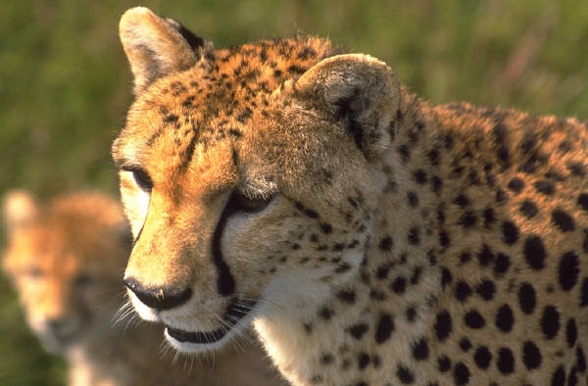 | 